1KC (Sth) 2023 – Briefing

This ride usually includes starts at Wellington, Masterton, Napier & Palmy. As per last year, the Wellington start is over ½ an hour between 0630 – 0700.
Start:-
Wgtn - Z Rimutaka (nee Caltex): Check-in and depart from 0630 until 0700
No one has mentioned any organised starts at the other locations, but feel free to contact us regarding this

Identification:-
We will issue Yellow&Black ribbon to tie to the rear of your bikes. This is for you to be able to identify 1KC riders on the road and so you don’t get led astray by a non-IKC rider! Ken will have these in Masterton, the Palmy riders can get theirs at Caltex Rimutaka.

Groups:-
Try to ride in groups or pairs. At least that way, if something goes wrong you will have help at hand. With the staggered start, you may want to pre-arrange your groups, or turn up early to wait for riders you know. Alternatively, let us know and we can put your details on one of these bulk emails for other riders to contact you.
Any offs or withdrawals ring or text John. Numbers are on the Ride Instruction Sheet

Places to watch:-
Most of the ride is on main roads but watch for critters (C) and loose bits (L), especially in these days of weather related slips and lack of timely road maintenance.
- Potholes throughout Taranaki
- Critters & Loose stuff through Aria area

Fuel Stops
It’s an easy free flowing route with plenty of fuel stops along the way.

Marking your Route
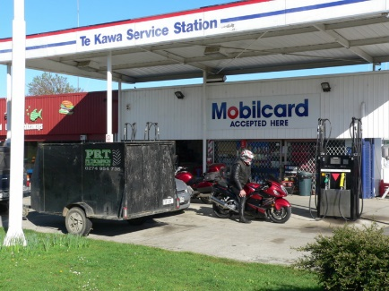
You need to take digital photos as evidence you have done the required 1000Kms because we are not taking odo’ readings. (Refer to Checkpoints Doc for the listed pix stops)

The digital photo of your bike should be in front of signage or a landmark that clearly identifies the location. These will be checked prior to issuing certificates when you get in.

Potential Lunch Stops:-
….Hell, who will have time for lunch??!! But if you feel you have to, there are plenty of cafes up around New Plymouth.

Finish
1841 Restaurant & Bar:-
This is anew venue for us, due to the Backbencher ceasing weekend trading. This location is easier to get in and out of and parking is easy here with it backing onto the Countdown Carpark. (Ride pix refers).
Check in with John who will be there from/before 1800 (6pm) to check your receipts/photos and issue Certificates. We should have a large table reserved for us and you can have sit-down meals or bar snacks.
If you are likely to finish after 2200 (10:00pm), please text John on 021 0267-8544, then email your pix through to distanceriders@gmail.com and the certs etc will be mailed out.

Spot Prizes.
We will pre-draw the prizes on the Friday night and they can be collected at the start or finish.

Badges
These are included as the entry fee and collected on completion of the ride, along with the certificates.
Proceeds from this ride go towards Christmas Presents for children with Muscular Dystrophy in the Central & Lower North Island. Any excess will be presented to the MDA.

General:-
This is not a race and participation may include riders from Restricted Licence holders to very experienced, hard-arsed endurance riders and bikes from 250’s to 1800’s, adventure bikes, cruisers, sprotties & tourers. The route is generally on main roads to provide a free-flowing ride so the quick and the ‘hard-arses’ will start coming in within 11-12hours (you may have to wait for Brett to get there) and most should finish within 13 - 14hours. This will be easily achievable by minimising stops rather than increasing speed. Please ride at your own pace and respect your fellow riders, feel free to pass slower riders but please don’t carve-them-up. We’re here for a good time and I hope you all enjoy this intro to endurance riding and perhaps we’ll see you at the next NI1600, or TT2000…..……or 4 Points……or the next time you feel like going 700Km for an ice-cream or to soak in a hot pool!!

Make it a Great Day!

